School Project Prototype

Context

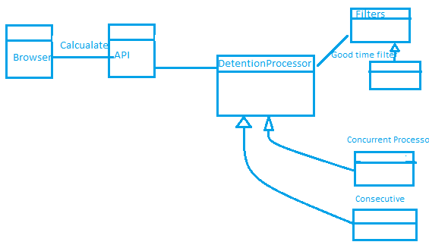

Calculate request goes to the API server which internally initialize a Detention processor. It dynamically validates the Detention using a series of active Filters. Then the request delegated to a specific processor

Project Architecture

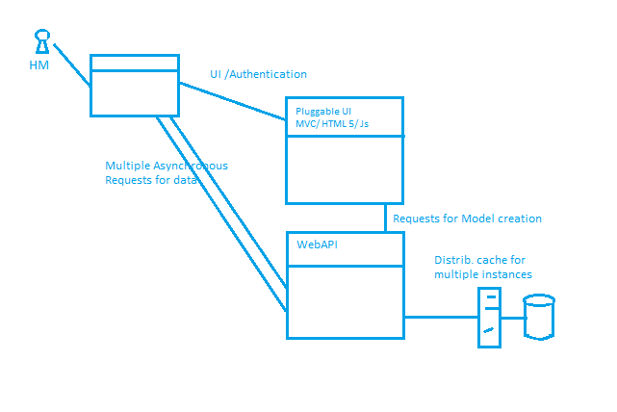

## Functionality

Encapsulated in the Processor

## Security:

Asp.Net membership for the UI

And Owin based token for WebAPI

## CAP:

For more performance and availability, Stateless API Can be scaled with a distributed caching mechanism like Redis. UI server also can be deployed in Load balancer environment

## Integration/ Load Tests

Are not included

### ORM

EF for Model creation and a micro ORM like dapper for performance needed operations

### Logging/Exceptions

Log4net logger – logs excptions